Axos BankTM Portfolio Wholesale Guidelines

Contents: Ctrl click heading below to be directed to appropriate section

1031 Exchange
Adverse Credit
Agricultural Properties
Alimony/Child Support Income
Alimony/Child Support Debt
Appraisals
Asset Depletion
Authorized User Accounts
Auto Allowance
Bankruptcy/Foreclosure/Short Sale
BDTI Calculation/Properties Pending Sale
Boarder Income
Borrower Eligibility
Bridge-to-Sale Loans
Business Assets
Business Debt in Borrower’s Name
Capital Gains
Cash Recapture
CEMA
Commission
Condominiums
Condotels
Consumer Credit Counseling (Previous Participant)
Currency Conversion
Cooperatives
Corporation Income
Co-Signed Debts
Court Ordered Assignment of Debt
Credit History
Credit Scores
Cross Collateral
Deferred Installment Debt
Depository Accounts
Dividend/Interest
Earnest Money Deposit
Employee Business Expenses
Employment Offers or Contracts
Fixed Income
Flood Insurance
Foreign Credit Reports and Credit Scores
Foreign Income
Gifts
Hazard Insurance
Home Equity Line of Credit Payment
Income Tax Payment Plan
Inquiries
Installment Debt
Interest Only
Interested Party Contributions
Investor Owned Residential Real Estate
IRA and Annuity Distributions
IRS 4506T
Leaseholds
Lease Payments
Life Insurance Cash Value
Liquid Assets
Loans Secured by Financial Assets
Loans to One Borrower
Loan-to-Value
MERS
Mold Inspection Report
Mortgage Assumptions
Mortgage History
Mortgagee Clause
Non Arm’s Length
Non Occupant Co-Borrowers
Non Traditional Credit
Non-Depository Assets
Notes Receivable
NRA Borrowers
Option to Purchase
Overtime & Bonus
Part Time and/or Second Job
Pledged Assets
Power of Attorney
Prepayment Penalty
Private Road
Proceeds from Pending Sale of Real Estate
Properties (Acceptable/Unacceptable)
Property Flips
Property Taxes
Qualifying Rate
Rate Lock Procedure (Online)
Recent Construction
Refinance Rate and Term
Refinance Cash-Out
Rental Income
Rental Payments
Reserve Requirements
Retirement Accounts
Revolving Debt
Royalty Income
Rural Properties
Self-employed Income Documentation
Servicing Information
Solar Lease / Power Purchase Agreement
Square Footage
Subordinate Financing
Student Loans
Tax Returns on Extension
Tenants in Common
Termite Report
Third Party Authorization
Trust Entity Vesting
Trust Account Assets
Trust Income
Unacceptable Sources of Income
Verification Documents
Wage Earners
Well Certification

PLEASE NOTE IF YOU HAVE A LOAN REQUEST THAT IS NOT ADDRESSED IN THIS MATRIX OR MAY BE AN EXCEPTION TO THE GUIDELINES SHOWN HERE, CONTACT YOUR ACCOUNT EXECUTIVE TO DISCUSS IT.

Axos BankTM SFR Portfolio Matrix
1031 Exchange | Assets for the down payment from a "like-kind exchange," also known as a 1031 exchange, are eligible if properly documented. The following documents are required:  - The Closing Disclosure for the property sold by the borrower as part of the exchange  - A statement from the accommodator holding the funds verifying the funds held for the borrower
Adverse Credit | Collection accounts and judgments of minimal amounts require a satisfactory explanation and review by the underwriter to determine if the open account will impact the applicant’s ability to keep payments current or if the payoff is required prior to or at closing. Collections and judgments greater than minimal amounts should be determined by the underwriter if they should be paid off prior to or at closing, unless a valid dispute exists, is fully verified, and well-documented. All tax liens must be satisfied prior to or at closing.
Agricultural Properties | Residential properties that are partially utilized for agricultural purposes are eligible, if the agricultural activities represent the borrower's hobby. Hobby is defined as an activity that generates less than 10% of the borrower's gross income. Properties with a commercial business and/or commercial buildings are not eligible.
Alimony/Child Support Income | Document that alimony or child support will continue to be paid for at least three years after the date of the mortgage application, as verified by one of the following:  - A copy of a divorce decree or separation agreement (if the divorce is not final) that indicates payment of alimony or child support and states the amount of the award and the period of time that it will be received. If a divorce decree, separation agreement, or other legally binding court document is provided  - If the borrower is recently separated or divorced and the payment is established (received for a minimum of one month), the income can be considered with documentation that shows 6 months of payments made by the former spouse.  Note: If a borrower who is separated does not have a separation agreement that specifies alimony or child support payments, it is acceptable to consider any proposed or voluntary payments as income with supporting documentation and reasonable rationale. A history of receipt should be documented, if there is no formal agreement.  - Any other type of written legal agreement or court decree describing the payment terms for the alimony or child support may be reviewed.  Any non-taxable portion of child support may be grossed up 125%.  Limitations on the continuance of the payments, such as the age of the children for whom the support is being paid or the duration that alimony is required to be paid, should be identified.
Alimony/Child Support Debt | - Alimony is treated as a reduction in income.  - Child support/maintenance is treated as a monthly debt obligation.  The amount of such payments should be documented. Proof that these amounts are being paid may be required. These obligations should be disclosed on the application and considered a recurring debt if more than 10 months of payments remain. The divorce decree is reviewed to determine number of months the obligation will remain. If the ages or date of birth of children is not specified in the divorce decree, birth certificates are requested to determine when the support will cease.
Appraisals | An appraisal report is valid for four months preceding the date of note and closing documents and the appraisal report must not be more than 12 months old. If the appraisal report is greater than 4 months old on the date of the note and mortgage, then an appraisal update is required.  The appraiser must inspect the exterior of the property and review current market data to determine whether the property has declined in value since the date of the original appraisal. This inspection and results of the analysis must be reported on the Appraisal Update and/or Completion Report (Form 1004D). At a minimum, when completing the Appraisal Update portion of the report, a photograph of the front of the subject property must be included.  NOTE: Axos Bank adheres to a policy of selecting the most reliable appraisal, as stated in Section II of AIR.  As such, mortgage brokers and correspondent lenders are prohibited from ordering additional appraisals in an attempt to influence the outcome of the first or second appraisals or for value shopping purposes.  If mortgage brokers or correspondent lenders would like a replacement appraisal, the Appraisal Manager or designee for Axos Bank must approve doing so PRIOR TO ordering the replacement appraisal.
Asset Depletion | Asset Depletion is a method of calculating a monthly income stream based on a borrower’s assets. Asset depletion can be utilized on any scenario, at any LTV, and with any product; however, asset depletion on loans to non-resident aliens require additional review.  The Asset Depletion Calculation is based on the current value of the assets, amortized over 30 years or until the borrower turns 85 with a minimum of 10 years. For borrowers over the age of 85, a minimum of 5 years is applied. The prevailing interest rate is used; (currently using 5%).  - Eligible assets should be held in a U.S. Bank;  - A minimum of $500,000 must be available for asset depletion;  - A minimum of 12 months PITIA in reserves is required;  - Assets must be liquid;  - Annuities and privately held stock are not eligible;  - Cash-out from a refinance is not eligible for Asset Depletion  - Retirement accounts are not eligible for depletion, unless the borrower is at least 59 1/2 years of age; if the borrower meets the age requirement, then 100% of the current value of these assets may be used for depletion;  - Checking accounts, savings accounts, trust accounts, CDs, cash value of life insurance (in the borrower’s name or the name of the borrower’s trust) are eligible. 100% of the current value of these assets may be used for depletion;  - Publicly Traded Stocks, Mutual Funds and Bonds are eligible. 75% of the current value of these assets may be used for asset depletion;  - Asset depletion may not be used if gift funds are present;  - Borrower must be 100% owner of assets utilized;  - Business funds excluding assets in an operating account, may be utilized on an exception basis, if the borrower is 100% owner of the business and a signed letter from a CPA, accountant, or financial officer at the business stating that the borrower is authorized to use the funds, and that doing so does not adversely affect the business should also be obtained;  - For loans where asset depletion is the only source of qualifying income, further exploration of the borrower’s asset pattern is warranted; and  - Assets currently being drawn on for monthly income in the form of monthly distributions, interest income, or dividend income can be utilized if the interest/dividend or other payment is not already being counted in the income calculation.  - Monies replenished as part of a cash recapture transaction cannot be used for asset depletion
Authorized User Accounts | An authorized user is a person permitted by a credit account holder to use an account. Typically, this facilitates a family member who is trying to manage and build credit for the first time. Only accounts identified with either an Individual or Joint account indicator should be considered as part of the applicant’s credit history.
Auto Allowance | An auto allowance may be included as income, if the allowance is typical for the applicant’s occupation. The auto allowance should be verified by the employer or shown on applicant’s federal income tax returns. Depreciation on the car may not be added back to income.  The full amount of an auto allowance should be counted as income. Any payment for a corresponding identified auto loan should be counted as a liability if applicable.
Bankruptcy/Foreclosure/Short Sale | Generally, no bankruptcies, foreclosures, or short sales are preferred. All submissions with histories of bankruptcies, short sale or foreclosures must be satisfactorily explained in writing by the Borrower. In addition, a three-year history of re-established and clean credit since any bankruptcy discharge is required. Extenuating circumstances may be reviewed. These may include, but not limited to: job loss, death of spouse, serious illness of the borrower or a family member, and job relocation. Current or prior foreclosures and short sales should have been completed no less than 3 years ago based on the borrower’s application date.
BDTI Calculation/Properties Pending Sale | Monthly payments reflected on the credit report (or other identifying sources,) and PITIA is utilized to calculate the back-end debt-to-income BDTI ratio.  If no monthly payment is indicated on the credit report, or if other forms of verification are not provided, payments the greater of $10, or 5% of the outstanding principal balance on the account will be projected.  If current primary, investment or second home property is listed for sale but not sold, the payment can be excluded from the BDTI calculation with the following: Copy of current listing agreement as well as an additional six months of the listed property's underlying PITIA cash reserves (over and above loan program reserve requirements). Additional reserves may be required depending on geographic area and marketing times.  The maximum BDTI is 60% for loan amounts over $2 million
Boarder Income | When a borrower with disabilities receives rental income from a live-in personal assistant, whether or not that individual is a relative of the borrower, the rental payments can be considered as acceptable stable income in an amount up to 30% of the total gross income that is used to qualify the borrower for the mortgage loan. Personal assistants typically are paid by Medicaid Waiver funds and include room and board, from which rental payments are made to the borrower. Income is shown as rental income on the borrower’s most recent tax returns.  The two most recent years’ of the borrower’s individual tax returns must reflect receipt of the boarder income (usually reported on 1040 Schedule E).
Borrower Eligibility | - U.S. Citizen  - Permanent Resident Aliens – Resident Alien Card required  - Non-Permanent Resident Alien – Visa or valid Passport required  These borrowers must meet Ability to Repay requirements.
Bridge-to-Sale Loans | Bridge to Sale financing is available on loans made on owner-occupied, second home, or investment 1-4 unit properties (no condominiums or cooperatives) in NON-JUDICIAL FORECLOSURE States ONLY.  Properties listed in the following Judicial Foreclosure States are INELIGIBLE for the Bridge-to-Sale Loan Program:  - Judicial Foreclosure States: Connecticut, Delaware, District of Columbia, Florida, Hawaii, Illinois, Indiana, Iowa, Kansas, Kentucky, Louisiana, Maine, New Jersey, New Mexico, New York, North Dakota, Ohio, Oklahoma, Pennsylvania, South Carolina, Vermont, Wisconsin.  Loan amounts of $1,000,000 up to a maximum 55% LTV are offered. The LTV is based on the LOWER of: (1) the appraised value of the subject, or (2) the lowest list price listed in the 12 months preceding the loan application date. Additional program details below:  Loan Term / Renewal Option  - 1-year term with a renewable option  - 6-month renewal option available with a required 0.50% renewal fee  - An additional 6-month renewal option is available with another 0.50% renewal fee  - Review fee of $500.00 is required at the time the renewal option(s) is/are requested  Required Income Documentation  - 2 years’ individual tax returns (K-1’s and Business Returns not required)  Borrower Requirements / Source of Repayment  - Minimum credit mid-score 680  - NRA borrowers are not eligible for this program  - Borrowers must provide a letter and proof of assets or income that will be used to make the 12 monthly payments—NO NEGATIVE RATIOS ARE PERMITTED.  - NOTE: cash proceeds from the loan may be used as a source of making the 12 monthly payments  Interest Reserve Requirement  - Bridge-to-Sale loans require an interest account. The borrower must fund the account with 12 months-worth of the loan’s payments.  Appraisal Requirements  - Loan amounts in excess of $1,000,000 require 2 appraisal reports. One appraisal is ordered through an approved AMC; the second appraisal is engaged by the Residential Appraisal Manager  - Rental surveys are required on ALL loans  Listing Requirements  - Average marketing time for the neighborhood should be reasonable  - Subject property must be listed  Financing Options  - Interest only  - No subordinate financing  - No cross collateral financing  Required Disclosures / Post-funding Documentation Collection  - TRID disclosures, extension addendum  - Bank to request updated financial information from the borrower at the time a renewal option is requested
Business Assets | Business assets may be acceptable sources of funds for the down payment, closing costs, and required reserves when a borrower is self-employed. The following applies:  - The borrower must be an owner of the account, which must be verified by tax returns or other documentation.  - The impact on the business should be considered to confirm that the withdrawal of funds for this transaction will not have a negative impact on the enterprise.  - The borrower should be at least 50% owner of the business and available assets will be limited to his/ her percentage of ownership in the business.
Business Debt in Borrower’s Name | When a self-employed borrower claims that a monthly obligation that appears on his or her personal credit report is being paid by the borrower’s business, it must be verified that the obligation was actually paid out of company funds and was considered in the cash flow analysis of the borrower’s business.  The account payment does not need to be considered as part of the borrower’s individual recurring monthly debt obligations if:  - The account in question does not have a history of delinquency;  - The business provides acceptable evidence that the obligation was paid out of company funds (such as 6 months of canceled company checks); and  - The cash flow analysis of the business considered the obligation.  The account payment is part of the borrower’s individual recurring monthly debt obligations, if any of the following situations exists:  - If the business does not provide sufficient evidence that the obligation was paid out of company funds;  - If the business provides acceptable evidence of its payment of the obligation, but the cash flow analysis of the business does not reflect any business expense related to the obligation (such as an interest expense—and taxes and insurance, if applicable—equal to or greater than the amount of interest that one would reasonably expect to see given the amount of financing shown on the credit report and the age of the loan). It is reasonable to assume that the obligation has not been accounted for in the cash flow analysis; or  - If the account in question has a history of delinquency. To ensure that the obligation is counted only once, adjust the net income of the business by the amount of interest, taxes, or insurance expense, if any, that relates to the account in question.
Cash Recapture/Delayed Financing | Loan used for the purpose of recapturing funds used to purchase a property acquired, or pay off a loan obtained to acquire the property, within 12 months of the date Axos receives the loan application, may use purchase loan to value ratio guidelines. The source of down payment documentation is required. The lesser of the sales price or appraised value is used.
CEMA | - Provide copies of all original prior notes (and GAP notes). Lost note affidavits are accepted on a case by case basis.  - Confirm new money amount with Closing Attorney  - Exhibit A must list all Notes, Security instruments, assignments that modify, consolidate or extend prior underlying obligations and which predate the CEMA
Capital Gains | Borrowers whose income is generated primarily through real estate investments, or the sale of other assets that are claimed on Schedule D of the Federal Income Tax Return (form 1040), must demonstrate a two-year history of receipt on their tax returns. The borrower must also have sufficient assets to support the continuity of capital gain income. Generally, a 24-month average of the income is utilized.  Carefully evaluate the borrower’s ongoing income and provide supporting documentation to demonstrate the likelihood of continuance.  If the borrower has recently begun to receive capital gains, or the most recent year of capital gains showed an increase, obtain an explanation and supporting documentation to evidence why the most recent year should be utilized in lieu of a two-year average.
Commission | A minimum history of two years of commission income is recommended. The following documentation should be reviewed to determine the amount of commission income used for qualifying:  - The borrower’s two most recent paystubs and IRS W-2 forms covering the most recent two-year period. I.e. a final paystub from the applicable year should show the commission wage broken-out from other wage income.  - Additional documentation may be required if the commission income is not clear in the paystubs and W2 forms.
Condominiums | Condominiums are limited to those geographic areas where condominiums are common and customary.  All loans secured by condominiums require a completed project questionnaire/certification.  If the condominium is located in a judicial foreclosure state, and an LTV deviation has been granted, the borrower will be required to pledge 12 months of HOA dues in an account at the Bank.  Pending Litigation – The following documentation is required:  - Copy of the lawsuit or summary letter from the association’s attorney outlining possible outcomes.  - Current copies of applicable association insurance policies.  - Current Statement of Financial Position or Balance Sheet, Statement of Cash Flows or Cash Flow  - Analysis and Current Budget for the association.  - Comments from appraiser addressing the effect on marketability and any construction quality issues.
Condotels | Condotels are allowed on a case-by-case basis, and must be in an established project.  All condotels have a maximum 50% LTV.
Consumer Credit Counseling (Previous Participant) | Borrowers that have completed a credit counseling program will be considered as long as there is a minimum of 48 months seasoning on re-established credit since the credit counseling was terminated. The re- established credit may not include accounts paid through credit counseling.
Currency Conversion | Use the website below for any currency conversions:  https://www.oanda.com/currency/converter/
Cooperatives | - Cooperatives are limited to NY State only.  - A cooperative questionnaire is required.  - Collateral Requirements: stock certificate - proprietary leases and one security instrument
Corporation Income | Corporations use IRS Form 1120 to report taxes. The cash flow analysis can only consider the borrower’s share of business income or loss taking into consideration adjustments when the borrower owns 50% or more of the business.
Co-Signed Debts | Co-signed debts will not be counted in the BDTI ratio, if sufficient proof is provided that the Co-Signed primary debtor makes the payments and the payments have not been delinquent for the most recent 6 months.
Court Ordered Assignment of Debt | When a borrower has outstanding debt that was assigned to another party by court order (such as under a divorce decree or separation agreement) and the creditor does not release the borrower from liability, the borrower has a contingent liability. It is not required to count this contingent liability as part of the borrower’s recurring monthly debt obligations, but will be considered in the overall credit decision.
Credit History | Generally, borrowers with credit delinquency will be scrutinized closely and should be addressed by the underwriter on loans being approved with appropriate compensating factors. Extenuating circumstances will be considered with a letter of explanation from the borrower. Borrower(s) should exhibit at least four active major consumer credit and /or mortgage accounts; however, borrower(s) with no credit history will be considered on a case-by-case basis. (See Non Traditional Credit)
Credit Scores | The lowest middle credit score from all borrowers will be utilized to determine program eligibility.  - Foreign borrowers do not have a traditional U.S. credit score and as such are exempt from this guideline.  Any exceptions to the FICO requirement should be carefully considered and the exception must be reasonable and well documented.
Cross Collateral | The cross collateral program generally allows up to 90% financing of the eligible property value (the lesser of the appraised value or the purchase price), and, in certain cases (see below), an allowance for the borrower to elect not to make a down payment.  Generally, the minimum cash down payment required is as follows:  - 10% cash down required for owner-occupied properties  - 20% cash down required for second home or investment properties  100% financing may be available if the following three conditions are met:  - Purchase transactions ONLY  - Effective LTV that is AT LEAST 10% below the published threshold for the transaction  - 12 months’ all mortgage payments held in liquid reserves  - No gift funds are part of the transaction  Effective LTV is calculated by dividing the loan amount by the total, summed value of both properties.  Example: Owner Occupied Property  Property A Lesser of Purchase Price or Appraised Value $2,000,000  Property B Appraised Value $2,000,000  TOTAL VALUE $4,000,000  90% of Purchase Price Property A $1,800,000  Existing Loan Property B $ 500,000  Loan Amount Required $2,300,000  Cash Required $ 200,000  Effective LTV 57.5%  Other Cross Collateral Requirements:  - Primary residences, second homes, and investment properties may be crossed with the subject;  - NOTE: properties located in Washington DC, West Virginia, and Virginia may not be used for a cross.  - The second piece of real estate must be owned by the borrower;  - Axos Bank should be in first lien position on both properties (deviations from the guideline are allowed, if there is an abundance of equity). These deviations must be reasonable and well-documented;  - An appraisal report will be required from an approved AMC for both properties as follows:  - For loan amounts up to $1 million: one report for the subject property and one for the cross property  - For loan amounts over $1 million: two reports for the subject property and one for the cross property  - A preliminary title report is required with lender’s coverage on both properties;  - Proof of hazard insurance for both properties  - Proof of flood insurance for both properties (if applicable)  - Property taxes due within 60 days must be paid current on both properties  - 2 recording fees if properties are located in different counties  - One note and one mortgage will be executed and will be recorded against both properties for the total loan amount (unless the properties are in different counties in which case 2 mortgages will be recorded – 2 recording fees)
Deferred Installment Debt | Deferred installment debts must be included as part of the borrower’s recurring monthly debt obligations. For deferred installment debts, other than student loans, if the borrower’s credit report does not indicate the monthly amount that will be payable at the end of the deferment period, copies should be obtained of the borrower’s payment letters or forbearance agreements, so that a monthly payment amount can be determined and utilized in calculating the borrower’s total monthly obligations.  Deferred student loan payments will not be included as a recurring monthly expense unless repayment begins within 12 months of the conditional approval date.
Depository Accounts | Funds held in a checking, savings, money market, certificate of deposit, or other depository accounts may be utilized for the down payment, closing costs, and financial reserves. The funds must be verified. Unverified funds are not acceptable for the down payment, closing costs, or financial reserves. Any indications of borrowed funds must be investigated.  It is acceptable to utilize two months or quarterly account statements, to verify that a borrower has sufficient funds for closing, down payment, and/or financial reserves. This documentation should include the following information:  - Clearly identify the borrower as the account holder;  - Include the account number;  - Include the time period covered by the statement;  - Include all deposits and withdrawal transactions (for depository accounts);  - Include all purchase and sale transactions (for financial portfolio accounts);  - Include the ending account balance.
Dividend/  Interest | Obtain 2 years’ tax returns. Verify the borrower’s ownership of the assets where the interest or dividend income was earned.  Documentation of asset ownership must be verified and a two-year history of receipt of the income by:  - Copies of the borrower’s signed federal income tax returns, or  - Copies of account statements.  An average of the income received for the most recent two years is developed. Any assets utilized for down payment or closing costs must be subtracted from the borrower’s total assets before calculating expected future interest or dividend income.  Interest and dividend income cannot be utilized in conjunction with asset depletion, unless the source of the interest or dividends is not included in the asset depletion calculation (e.g. when the source of the interest and dividend income is from ownership interest in a business). When including both, the likelihood that the dividends and/or interest would reasonably continue must be reasonable and well-documented.
Earnest Money Deposit | - If a copy of the cancelled deposit check is utilized to document the source of funds, the bank statements should cover the period up to (and including) the date the check cleared the bank account.  - If it cannot be determined that these funds were withdrawn from the borrower's account, additional verification of the source and evidence that the funds have actually changed hands from the borrower to the seller, the realtor, the escrow agent, or the settlement attorney should be provided.  - Large earnest money deposits and deposits that exceed the amount customary for the area should be closely evaluated.
Employee Business Expenses | Unreimbursed employee business expenses are not required to be analyzed or deducted from, or added to, monthly liabilities.  This applies regardless of whether unreimbursed employee business expenses are identified on tax returns or tax transcripts
Employment Offers or Contracts | If the borrower is scheduled to begin employment after the loan closes, it is acceptable to utilize an offer or contract for future employment and income to underwrite and close the loan.  If a borrower was previously employed as a W-2 wage earner and recently became a partner (e.g. law firm), obtain a copy of the contract. Any guaranteed draws are eligible for qualifying. If the borrower is not guaranteed a draw, but the employer makes a reasonable projection as to the future earnings of the borrower, the income can be utilized; however, supporting documentation to show likelihood of continuance for at least three years must be provided
Fixed Income | Social Security, Disability, Pension and/or VA Benefits  Obtain the most recent 1099’s or tax returns; if the income is non-taxable it can be grossed up 125% for qualifying purposes.  For new or increased distributions, the most recent award letter, policy statement, or benefit statement, as well as proof of receipt of the increased award should be obtained.  For borrowers on temporary leave, all of the following documentation must be obtained:  - A borrower-signed LOE confirming their intent to return to work  - Confirmation of the agreed-upon return date (this may be included in the LOE, in correspondence between the borrower and employer/employer’s third party administrator, or a printout from the employer/employer’s third party administrator)  - A verbal or written VOE  - Confirmation of the amount and duration of the borrower’s “temporary leave income” as well as their “regular employment income,” (this may be provided by the borrower, the employer, or the employer’s third party administrator)
Flood Insurance | All properties located in a flood zone will require flood insurance  - If the property is in a flood zone, the flood insurance is required to be impounded (unless the Master HOA insurance covers and pays for the flood insurance).  - If the property is located in an SFHA, borrowers must be notified within a reasonable time (generally, at least 10 days) before loan closing. The Special Flood Hazard Determination Notice must be wet-signed and dated. Axos Bank does not currently accept a digitally signed or PDF-signed notice.  - The minimum amount of insurance coverage required must be equal to the lesser of: the outstanding principal balance of all loans secured by the property; the maximum amount available under the NFIP  - The community must participate in the National Flood Insurance Program (NFIP)  Evidence Flood Insurance as follows:  - A copy of the Declaration Page  - A copy of the flood insurance application and evidence of premium payment for purchases only.  - For purchases, the Flood Policy must be in effect and paid before the borrowers sign loan documents. Provide proof of payment.  - Please Note: The NFIP does not recognize binders or certificates of insurance.  Flood Insurance Declaration  - Must reflect the same flood zone as the flood certification and appraisal  - The deductible may not exceed a maximum of:  $10,000 – Residential  $25,000 – Condos  - Subject property address and unit number must match the application  - Policy number must be listed  - Axos Bank listed as the Mortgagee  - Policy must be paid current  - If the policy is up for renewal within 60 days, the renewal premium and policy are required.  Condo Flood Insurance:  Condos require a NFIP Residential Condominium Building Association Policy (RCBAP)  Coverage required  - Total number of units in condo building multiplied by $250,000 or  - Outstanding principal balance of the loan or maximum available under NFIP, whichever is less  - If the unit’s portion of the RCBAP is insufficient to meet the regulatory purchase requirements, borrower to ask the association to carry adequate limits or borrower to purchase a separate dwelling policy.  Detached Structures:  - Flood insurance shall not be required in the case of residential property, for any structure that is part of such property, but is detached from the primary residential structure of such property and does not serve as a residence.  - Note: All residences such as guest cottages on the property, will require flood insurance. Barns, detached garages, workshop, etc. will not require additional flood coverage.  - The coverage required is the lesser of RCV, NFIP Maximum and the loan balance.  Private Flood Insurance policies for SFR only:  - Private flood insurance policies are only accepted if they meet all the same criteria as a NFIP Policy.  - Provide a copy of the full private flood insurance policy for our review.
Foreign Credit Reports and Credit Scores | It is appropriate to use a credit report from a foreign country to document a borrower's credit history. If a foreign credit report is not available, request 2 alternative credit references. If the reference is not in English, it must be translated by a certified translator.  If fewer than 2 alternative trade lines are available, the underwriter should carefully evaluate the borrower’s credit depth to determine qualification. Credit outside the U.S. may not meet the same standards as credit within (many Countries do not extend revolving credit to borrowers). Consequently, letters of reference regarding banking relationships may be utilized to help determine qualification.  A zero "0" credit score is used in the absence of a credit score for an NRA borrower and not an exception to a minimum credit score requirement. The underwriter may utilize alternative methods to document satisfactory evidence of borrower history to repay debt obligations in this circumstance
Foreign Income | If a borrower (U.S. Citizen, Permanent Resident Alien or Non-Permanent Resident Alien) is employed by a foreign company, U.S. tax returns to support the foreign tax credit must be obtained.  U.S. citizens, PRAs and NPRAs may NOT qualify solely on foreign tax returns.  Additionally, foreign tax returns, if applicable, may be required at the underwriter’s discretion.
Gifts | A borrower of a mortgage loan secured by a principal residence, second home, or investment property may utilize funds received as a personal gift from an acceptable donor. Gift funds may fund all or part of the down payment, closing costs, or financial reserves subject to the minimum borrower contribution requirements below:  Acceptable Donors:  A gift can be provided by:  - A relative, defined as the borrower's spouse, child, or other dependent or by any other individual who is related to the borrower by blood, marriage, adoption, or legal guardianship  - A fiancé, fiancée, or domestic partner.  - Entities including churches, municipalities, nonprofit organizations (excluding credit unions), a regional Federal Home Loan Bank under one of its affordable le housing programs, and public agencies. Gift funds may be received from well-known NGOs such as The Red Cross, IFRC (Red Crescent), United Nations Refugee Agency, International Rescue Committee, or other recognized refugee programs with verification of the donation.  NOTE: The donor may not be, or have any affiliation with, the builder, the developer, the real estate agent, or any other interested party to the transaction.  Documentation Requirements:  Gifts should be evidenced by a letter signed by the donor, called a gift letter. The gift letter should:  - Specify the dollar amount of the gift;  - Specify the date the funds were transferred;  - Include the donor's statement that no repayment is expected; and  - Indicate the donor's name, address, telephone number, and relationship to the borrower.  It should be verified that sufficient funds to cover the gift are either in the donor's account or have been transferred to the borrower's account. Acceptable documentation includes the following:  - A copy of the donor's check and the borrower's deposit slip;  - A copy of the donor's withdrawal slip and the borrower's deposit slip;  - A copy of the donor's check to the closing agent; or  - A settlement statement showing receipt of the donor's check  - On Non-Resident Alien (“NRA”) loans a copy of the donor’s depository account statement must be provided and reviewed by Compliance.  When the funds are not transferred prior to settlement, it should be documented that the donor gave the closing agent the gift funds in the form of a certified check, a cashier's check, or other official check.
Hazard Insurance | Hazard insurance (if applicable) will be required. Borrowers who are not establishing an escrow account for hazard insurance, that have a monthly direct payment plan for their hazard insurance, do not have to prepay the current year of hazard insurance at closing as long as supporting documentation is obtained to show that the monthly direct payment plan is current.  Hazard Insurance (HO3) coverage:  - Declaration page with coverage, premium amount, agent, phone, loan # and mortgagee clause to read: Axos Bank, Its Successors and/or Assigns, P O Box 401420, Las Vegas, NV 89140  - Dwelling coverage must cover the lesser of loan amount or estimated cost new from the appraisal.  - Replacement cost estimator from insurance agent on an exception basis  - Loan amount <$1,000,000 - max deductible cannot be more than 1% of policy face amount or $5,000, whichever is the lesser.  - Loan amount > or equal to $1,000,000 - max deductible is $10,000  - Must include current balance owed for refinance transactions.  - Policy must be for a 12-month term  - Any outstanding balance or premium hazard due within 60 days of funding date must be collected and/or paid in full by closing  - Insurance should be in the name of the borrower as shown on the Note and not an entity. If policy is in name of an entity the borrower must be listed as an “additional insured”.  - Subject property address and unit number (if applicable) must match the address as shown on the Note  Condo (HO-6) coverage:  - Condos require separate "walls-in" coverage if the HOA's Master Policy only covers the exterior.  - Provide declarations page showing coverage amount, borrower name and subject property address.  - Coverage required is 20% of Appraised Value.  - Mortgagee clause to read: Axos Bank, It's Successors and/or Assigns P O Box 401420, Las Vegas, NV 89140  - Max deductible cannot exceed 5% of the face amount of the policy  - Policy must be for a 12-month term  - Any outstanding balance or premium hazard due within 60 days of funding date must be collected and/or paid in full by closing  - Insurance should be in the name of the borrower - not an entity. If policy is in name of an entity the borrower must be listed as an “additional insured”.  Master Condo Insurance:  - Declaration page showing adequate coverage, deductible and insurance agent's name and phone number.  - Must have a minimum of $1 million liability coverage.  - Declaration page to include replacement cost endorsement (100%) or guaranteed replacement cost endorsement.  - Must reflect all borrowers' names, subject property unit number and total number of units within the complex.  List loan number and mortgagee clause to read: Axos Bank, Its Successors and/or Assigns, P O Box 401420, Las Vegas, NV 89140  - If the Master Policy includes both Building and Walls-In Coverage, it must be noted on the Policy. In that case, the HO6 policy will be N/A.
Home Equity Line of Credit Payment | Current payments on home equity line of credit loans (“HELOC”) must be considered as part of the borrower’s recurring monthly debt obligations. If the HELOC does not require a payment, there is no recurring monthly debt or need to consider.
Income Tax Payment Plan | Income tax payment plans are not required to be paid off. The following requirements apply:  - A tax lien has not been recorded  - A letter of explanation regarding the reason for the plan is required  - A copy of the payment plan is required to verify the terms of the plan  - Payments must be current  - If more than six months is remaining on the plan, the payment is included in the ratios.
Inquiries | When the credit report indicates that recent inquiries took place, confirmation that the borrower has not obtained any additional credit (that is not reflected in the credit report or the mortgage application) is required.  If additional credit was obtained, a verification of that debt must be provided and the borrower must be qualified utilizing the monthly payment.
Installment Debt | All installment debt that is not secured by a financial asset, including student loans, automobile loans, and home equity loans, must be considered part of the borrower’s recurring monthly debt obligations, if there are more than ten monthly payments remaining. Pay-down of installment debt to ten or less monthly payments is allowed to assist in qualifying.
Interest Only | Interest-only payments are calculated using the greater of the start rate or fully indexed rate, utilizing a 25-year amortization term.
Interested Party Contributions | IPCs are costs that are normally the responsibility of the property purchaser, which are paid, directly or indirectly, by someone else who has a financial interest in, or can influence the terms and sale, or transfer of, the subject property. Interested parties to a transaction include, but are not limited to: the property seller, the builder/ developer, the real estate agent or broker, or an affiliate who may benefit from the sale of the property and/or the sale of the property at the highest price possible.  A lender or employer is not considered an interested party to a sales transaction unless it is the property seller or is affiliated with the property seller or another interested party to the transaction. IPCs are either financing concessions or sales concessions. The following are considered to be IPCs:  - Funds that are paid directly or indirectly from the interested party to the borrower;  - Funds that flow from an interested party through a third-party organization, including nonprofit entities, to the borrower;  - Funds that flow to the transaction on the borrower’s behalf from an interested party, including a third-party organization or nonprofit agency; and  - Funds that are donated to a third party, which then provide the money to pay some or all of the closing costs for a specific transaction.  - IPCs are limited to 6%, not to exceed actual closing costs
Investor Owned Residential Real Estate (IORR) | Loans on investment properties will be considered an Investor Owned Residential Real Estate (IORR) loan if ALL of the following conditions are met:  - The subject is an investment property;  - Rental income makes up the majority of the borrower’s income; and  - The loan amount requested is $3 million OR the borrower has an aggregate of $5 million in loans at Axos Bank.  Loans that have been designated IORR will be subject to additional, annual post-funding reporting requirements (e.g. rent rolls, balance sheet/P&Ls, tax returns, etc.)
IRA and Annuity Distributions | IRA distributions are eligible for qualifying, if a copy of the most recent 1099 or tax returns are obtained and verification that the borrower has sufficient funds in the IRA or Annuity account to continue the income distributions for at least three years.  - For new or increased IRA or Annuity distributions, it must be documented that sufficient assets are available using an increased distribution amount and that a revised or new distribution documentation is received from the advisor or depository.  NOTE: IRA distributions are only eligible for borrowers over 59 ½ years of age.
IRS 4506T | A signed IRS form 4506-T and Borrower's Certification and Authorization will be required for all loans. The 4506-T will be utilized to request tax transcripts.
Lease Payments | Lease payments must be considered as recurring monthly debt obligations regardless of the number of months remaining on the lease. Automobile leases should be considered a recurring obligation regardless of payments remaining unless the applicant can demonstrate cash assets to purchase or buy out the lease or eliminate use of the automobile.
Leaseholds | Leaseholds will be considered on a case-by-case basis, as approved by Credit Management. Generally:  - The leasehold estate and improvements must constitute real property subject to a mortgage lien and insured by a title policy.  - The lease must be valid and in full force and effect.  - All ground rent payments, other payments or assessments must be current and the borrower must not be in default under any other provision of the lease, nor may the ground rent owner have claimed such a default.  - The lease should guarantee the lender the right to receive at least 30 days' notice of default by the borrower and the option to cure the default or take over the borrower's rights.  - The lease should include provisions to protect the lender's interest in the event of a property condemnation.  - The lease should provide that the leasehold can be transferred, mortgaged and sublet an unlimited number of times without restriction or upon payment of a reasonable fee and delivery of documentation to the lessor. The lessor may not require credit qualification on any assignee or sub-lessee.  - The estate term should run through at least the term of the mortgage maturity unless fee simple title will vest at an earlier date in the borrower or a HOA and should be assignable or transferable. In cases where the term of the lease does not extend beyond the term of the loan, the borrower must have the ability to purchase the fee interest at the expiration of the lease.
Life Insurance Cash Value | Net proceeds from a loan against the cash value or from the surrender of a life insurance policy are acceptable sources of funds for the down payment, closing costs, and reserves.  If the funds are required for the down payment or closing costs, the borrower’s receipt of the funds from the insurance company must be documented by obtaining either a copy of the check or a copy of the payout statement from the insurer. If the cash-value of the life insurance is being utilized for reserves, the cash-value must be documented but does not need to be liquidated and received by the borrower.
Liquid Assets | Acceptable source of down payment, closing costs and reserves sources include:  - Checking or savings accounts  - Investments in stocks, bonds, mutual funds, certificates of deposit, money market funds, and trust accounts  - The amount vested in a retirement savings account  - Trade equity  - Savings bonds  - Trust accounts  - Proceeds from sale of real estate  - Deposits on sales contracts  - Repayment of loans  - Cash value of a vested life insurance policies  - Proceeds from a cash-out refinance transaction on subject property  - Gift funds  Unacceptable source of down payment, closing costs and reserves sources include:  - Funds that have not been vested  - Funds that cannot be withdrawn under circumstances other than the account owner’s retirement, employment termination, or death  - Stock held in an unlisted corporation  - Stock options and non-vested restricted stock  - Personal unsecured loans  - Interested party contributions (IPCs) that are not approved or exceed the amount allowed (See Interested Party Contributions)  - Sweat equity  - Bitcoin or other virtual currencies
Loans Secured by Financial Assets | When a borrower uses his or her financial assets—life insurance policies, 401(k) accounts, individual retirement accounts, certificates of deposit, stocks, bonds, etc.—as security for a loan, the borrower has a contingent liability.  It is not required to include this contingent liability, as part of the borrower’s recurring monthly debt obligations, provided a copy of the applicable loan instrument that shows the borrower’s financial asset as collateral for the loan is obtained.  If the borrower intends to use the same asset to satisfy financial reserve requirements, the value of the asset must be reduced (the account balance, in most cases) by the proceeds from the secured loan and any related fees to help determine whether the borrower has sufficient reserves.
Loans To One Borrower | 'Loans To One Borrower' verification form must be completed by all borrowers.  The form is located on the Axos Bank website under forms at https://www.axosbank.com/home-loans/third-party-lending/forms
Loan-to-Value | - Loan amount less than $1,000,000 – one appraisal required  - Loan amount greater than $1,000,000 = two appraisals required  - An appraisal review is completed of all appraisals by the Appraisal Department. The final determination of value concluded in the review is used to calculate value.  Purchase Transactions: generally, the lesser of appraisal review or purchase price is used to calculate LTV  Rate & Term (Limited Cash Out) Refinance Transactions: generally, the lesser of the appraisal review value or the appraisal value is applied. Based on the appraisal or appraisal review, if the property has been listed in the last 12 months, the value is based on the lower of the appraisal review value or the lowest listed sales price.  - NOTE: if the property has been listed for sale within 90 days of the application date, proof of the listing’s removal and an LOE from the borrower will be required  Cash Out Refinance Transactions: generally, the value is determined as follows—  - If the property was acquired more than 12 months prior to the application date, the appraisal review value should be used  - If the property was acquired within 12 months of the application date (based on the appraisal or appraisal review), the lower of the appraisal review value or the acquisition price should be used  - If funds are used to recapture amount paid for the property, purchase LTV may be utilized if B of I receives the loan application within twelve months of the close of the purchase escrow AND:  - Closing Disclosure issued at close of the purchase escrow.  - Documentation of source of funds used for down payment that must meet B of I requirements for down payment  - If the property was acquired within 12 months AND was subsequently listed within 12 months of the application date, the most recent event (acquisition or listing) should determine how the LTV is calculated  NOTE: A property must be off the market before receiving cash out on a refinance. Cash-out refinances are not eligible for properties that have been listed within 90 days of the application date.  Maximum financing may not be available for the following properties. A reduction to LTV will be required for each of these existent factors.  - Rural properties in area less than 25% built-up,  - Properties at the low or high end of the value range for the neighborhood,  - Properties in neighborhoods with declining market values or an over- supply of housing, or  - Areas with a marketing time of over six months.  Please refer to current B of I LTV Matrix for LTV guidelines.
MERS | MERS ID number is 1007359.
Mold Inspection Report | A mold inspection report will be required if mold or dampness is referenced in the appraisal.
Mortgage assumptions | If an applicant had a mortgage loan assumed by another party, the contingent liability may not be included in the applicant's underwriting ratios, if a copy of the formal assumption agreement (with or without release of liability) and evidence of the transfer of ownership are provided. This contingent liability should be apparent on the credit documentation.
Mortgagee Clause | Axos Bank, Its Successors and/or Assigns, P O Box 401420, Las Vegas, NV 89140
Mortgage History | Review the borrower's credit report to determine the status of all mortgage accounts. If a borrower had previous mortgages, a credit report, which includes a reference to the mortgage(s) and reflects twelve months of the most recent payment activity, is acceptable verification.  If adequate mortgage payment history is not included in the borrower’s credit report, the following must be utilized to verify the borrower’s payment history on a previous mortgage(s):  - A standard mortgage verification;  - Loan payment history from the servicer;  - The borrower’s canceled checks for the last twelve months; or  - The borrower’s year-end mortgage account statement provided the statement includes a payment receipt history, and, if applicable, canceled checks for the months elapsed since the year-end mortgage account statement was issued.  Loans with excessive prior mortgage delinquencies should not be eligible for exceptions to policy or deviations to guidelines. Excessive prior mortgage delinquency is defined as any mortgage trade line that has one or more 60-, 90-, 120-, or 150-day delinquency reported within the 12 months prior to the credit report date.
Non Arm’s Length | Transactions with Family Members - The following requirements apply when a non-arm’s length transaction involves a family member (specifically, the borrower’s spouse, registered domestic partner, fiancé or fiancée, child, parent, or any other individual related to the borrower by blood, adoption, or legal guardianship):  - An executed purchase or sales agreement between the purchaser and the family member is in the loan file.  - The source and ownership of funds for the down payment, closing costs, and reserves are well documented in the loan file.  - Seller may not be delinquent on their mortgage(s) or in a short sale transaction. A copy of the demand for payoff for the existing mortgage(s) should be obtained for verification.  - If the borrower is not providing a down payment towards the purchase of the home, the maximum LTV is 50%.
Non Occupant Co-Borrowers | A guarantor or co-signer is a credit applicant who may not have an ownership interest in the security property, but who signs the Note and thus shares joint liability of the note with the applicant who is the owner of the property.  The occupying borrower and non-occupying co-borrower must have sufficient combined income and liquidity to qualify under Axos Bank’s standard requirements. The use of a non-occupant co-borrower is limited to purchase transactions and rate and term refinance transactions.
Non Traditional Credit | If a borrower does not have the types of credit, which would appear on traditional credit reports, or if the borrower does not have sufficient number of credit references to develop a traditional credit report, it is acceptable to obtain alternative credit. Examples of non-traditional credit are:  - Cell phone payments;  - Utility bills;  - Rent payments; and  - Insurance payments.  A minimum of 2 non-traditional credit references are required, if non-traditional credit is utilized. If the borrower is not a U.S. Citizen and credit references are from another Country, the documentation must be translated by a certified translator.  Please contact your Account Executive if loan amount requests in excess of $500,000 require non-traditional credit.
Non-Depository Assets | Stocks, government bonds, and mutual funds are acceptable sources of funds for the down payment, closing costs, and reserves. Stock options may also be an acceptable source of funds, but only for down payments and closing costs.  - 70% of verified funds are utilized as reserves to account for market volatility.  - A statement verifying the borrower's ownership of the account or asset is required;  - The value of the asset at the time of sale or liquidation is used for qualifying assets; and  - The borrower's actual receipt of funds realized from the sale or liquidation of the assets, if the funds will be used for the down payment or closing costs should be verified.  - Deposits exceeding 50% of qualifying income must be explained
Notes Receivable | Note income is eligible for qualifying, if the borrower has a history of receipt of this kind of income documented on their tax returns. Copies of the notes will be required.  In cases where a borrower with an established history of note income has signed a NEW note, a copy of the note with documented receipt of the income is obtained. At a minimum, the remaining term should be three years of continuance. Secured notes are generally lower risk than unsecured notes
NRA Borrowers | A non-resident alien is defined as a borrower that does not live and work in the U.S. This does not include permanent resident aliens or non-permanent resident aliens. If borrowers do not have a valid work VISA, or work authorization card, and live and work outside the U.S., they are considered non-resident aliens. In addition, non-resident aliens are limited to loans on 2nd homes.  The following list contains the most common work visas that indicate a Due Diligence review is required (note, this list is not exhaustive):  - B-1, B-2  - BBBCV, C1  - E-1, E-2, EB  - F-1, M-1, J, TN  NOTE: additional documents may be requested as part of the Due Diligence review when there are NRA loans with gift funds (either from U.S. citizens or NRAs), and/or when there are NRA Title Holders or NRA Beneficial Owners.  All NRA loans are submitted for NRA Due diligence review and this is required prior to submission to underwriting. This may take a few days and require additional information. If approved the file will be submitted to Credit for an initial underwriting decision. The review fee is $250.  - Non-resident aliens must provide a valid passport;  - Minimum of 12 months PITIA is required in reserves;  - Investment properties may be considered case-by-case;  - Thorough online research of borrower name and business is required;  - Professional translation of all income/identity/asset documentation if not in English is required;  - Research country of origin;  - W8: is required at closing if borrower opens a Axos Bank Deposit account.  - Borrower is required to provide their Foreign ITIN on the W8 form  - Borrower is also required to provide their US ITIN on the W8 form (if they have a US ITIN)  - US ITIN/ W7: Cash out and investment loans:  - If the borrower gets out more than $100,000 cash out on a refinance, Axos Bank will require a US ITIN number (as the cash out is considered earnings)  - Axos Bank will also require a US ITIN number for all investment properties.  - W7: If borrower does not have US ITIN they must apply for one on the IRS W7 form.  - Proof of receipt of US ITIN will be a post funding condition. Correspondent is expected to follow up with borrower until US ITIN is received  - NRA Borrowers are not eligible for the Bridge to Sale Loan Program  Program Exclusions  - Applicants with diplomatic immunity are not allowed;  - POAs are not allowed;  - Vesting in an entity is allowed, but no part of the entity can be foreign  Income:  Two years’ tax returns are required from Country of Origin, if tax returns are filed in that country. They must be translated by a 3rd party professional translation company. Convert all currency into USD.  If tax returns are not required, then one or more of the following items of documentation may be obtained:  - CPA (or equivalent) letter verifying income,  - Paystubs or pay statements  - Letter from employer  All must be translated by a 3rd party professional translation company. Convert all currency into U.S. Dollar (“USD”).  Credit:  A minimum of two alternative credit references from Country of Origin are required, and may consist of:  - Mortgage or rental history  - Utilities  - Banking relationships  - Credit Cards  - Include the payments for the debt in the borrowers BDTI  - Housing payment is required  Primary Residence Expenses  Every NRA loan should include expenses for the primary residence such as rental payments, mortgage, taxes, insurance HOA dues and any other applicable expenses.  Assets:  Assets should be verified with two months’ statements from the borrower’s accounts. If the statements are not in English, they must be translated by a 3rd party professional translation company. Convert all currency into USD.  All foreign gift funds should be approved—all donors’ identities, sources of the funds, and employment require such clearance. The Bank will consider gifted funds from a maximum of 5 giftors and none may be, or have any affiliation with, the builder, developer, real estate agent, mortgage banker/broker, or any other interested party to the transaction.  Additional documents:  - US Mailing address must be provided for mailing of monthly statements
Option to Purchase | Rent credit for option to purchase is an acceptable source of funds toward the down payment. If the borrower has been in the home for 12 months, the current appraised value can be utilized to calculate LTV.  The original purchase option agreement is required. The amount of rent paid in excess of market rents as determined by a Rent Survey obtained by the Bank may be applied toward the required down payment. The Rent Survey must determine the market rents as of the time the original purchase option agreement was created and went into effect.
Overtime & Bonus | A minimum history of two years’ receipt is recommended. Borrowers relying on overtime or bonus income for qualifying purposes should have a prior history to be considered stable.  The following documents should be obtained:  - Completed VOE  - The borrower’s recent paystub and IRS W-2 forms covering the most recent two-year period.  Using biweekly overtime to qualify, analyze the most recent paystub to confirm that the earnings match the historic annual income values.  Borrowers using an annual bonus for qualification will have the annual amount divided by 12 to derive the monthly amount for qualifying purposes. If the borrower has a history of receipt, the prior year’s bonus may be utilized for qualifying even if the borrower has not received the bonus in the current year, as long as there is a contract or VOE to assess the likelihood of recurrence. Bonuses should demonstrate a stable or upward trend and may be averaged or otherwise justified based on underwriter discretion.
Part Time and/or Second Job | Verification of a minimum history of two years of uninterrupted secondary employment income is recommended.
Pledged Assets | The pledged asset program allows up to 90% financing of the property value (the lesser of the appraised value or the purchase price). The fee for pledged asset loans is $250.  Borrower Requirements:  The obligor (the party that pledges the eligible assets) does not have to be the borrower nor does the obligor need to have a family relation to the borrower.  Eligible Properties:  Residences, Second Homes, and Investment Properties  Not available in Washington DC, West Virginia, and Virginia.  Eligible Liquid Assets:  - Eligible Assets include stocks, bonds, CD’s, savings accounts and mutual funds.  - Eligible Assets must be managed by an Investment Broker/Dealer or  Axos Bank.  - Eligible Assets must be held in an account based in the U.S., either by a U.S. entity or the U.S. branch of a foreign entity.  - Eligible Assets do not include assets bought on margin, options, warrants, IRA assets, 401K assets, annuities, insurance benefits, and 529 or other education savings plans.  Securities Documentation  If securities are pledged, a review and approval of the securities is required:  - The borrower/obligor must execute the Pledge Agreement prior to loan funding; and  - The securities intermediary must execute the Account Control Agreement prior to loan funding. If the borrower is pledging funds outside of  Axos Bank, the control agreement must be reviewed and approved by legal. (3 Copies required- plus the securities intermediary’s business card)  - FR U-I Form must be completed and executed by borrower. Forms can be found at: https://www.federalreserve.gov/apps/reportforms/default.aspx  Pledge Amount:  The base pledge amount equals the equity requirement percentage multiplied by the property value (minus any equity or down payment).  The Initial Pledge Amount equals the Base Pledge Amount multiplied by two hundred percent (200%), if non cash and one hundred percent (100%), if cash.  The Minimum Pledge Amount equals the Base Pledge Amount multiplied by 168%.  - A Pledged Asset Account funded with 100% Cash Equivalent Assets has an Initial Pledge Amount and Minimum Pledge Amount equal to 100% of the Base Pledge Amount.  - Throughout the term of the pledge agreement, the obligor will be required to maintain a Pledge Account value equal to or above the Initial Pledge Amount. If the Pledged Account value ever falls to or below the Minimum Pledge Amount, the obligor will immediately be required to bring the Pledged Account value equal to or above the Initial Pledge Amount.  Calculating required pledge amount:  Example: Loan amount requested is 90% of the value (sales price or appraisal whichever is lower: $1,000,000 value $900,000 loan)  Identify the available LTV per the matrix and calculate the loan amount at that LTV: (e.g. max LTV is 70% - $700,000 loan, subtract this amount from the loan amount and the difference is the base pledge amount required. If the borrower is pledging cash the pledge required would be $200,000, and, if securities, the pledge required would be $400,000. In this example, the actual LTV is 90% and the effective LTV is 70%).
Power of Attorney | - The POA can be used for closing documents only, and is not acceptable for application or credit verification documents.  - Authorization allows for the attorney-in-fact to perform specific functions related to consumer loan financing or is specific to the subject property.  - The attorney-in-fact may not have any direct or indirect financial interest in the transaction (NOTE: a co-borrower may be the attorney-in-fact, however).  - The POA must be in full force and effect on the closing date, survives subsequent disability (durable), and has to be revoked in writing, or gives a specific expiration date that survives the closing date.  - A statement of the grantor's (applicant’s) name exactly as it will appear on all closing documents.  - Must be dated no more than 180 days prior to the closing date.  - The POA must be approved by the title company insuring the loan.  - POA may not be used to sign on behalf of a trustee for a loan using a trust  - POA is not eligible on Non Resident Alien loan.
Prepayment Penalty | 18 month hard prepayment penalty is charged on non-owner occupied portfolio loans (excludes NJ and OR)
Private Road | A property located on a private road must have a private road maintenance agreement.
Proceeds from Pending Sale of Real Estate | If the proceeds from the sale of a currently owned property are required for the down payment and closing costs on the new collateral, verify the source of funds by obtaining a copy of the final Closing Disclosure on the existing home before, or simultaneously with, the settlement on the new home. The document must evidence sufficient net cash proceeds to consummate the purchase of the new home.
Properties Acceptable/  Unacceptable | Acceptable Properties:  Single Family and 2-4 unit properties will be accepted. The mortgaged premises must be a detached or semi-detached dwelling, row housing, or unit within a condominium (“Condo”) project, Co-op or planned unit development (“PUD”)  Unacceptable Properties:  - Mobile homes;  - Raw land;  - Commercial properties;  - Multifamily housing greater than four units; and  - Rental properties rented for less than 30 days  Unique properties listed below will be considered on a case by case basis. The appraisal department is consulted prior to the origination of these property types.  - Geodesic domes;  - Berm homes;  - Earth homes; and  - Off grid homes
Property Flips | Properties owned by a seller for less than 6 months require an additional appraisal paid by the Bank if the following exists:  - More than a 10 percent price increase if the seller acquired the property in the past 90 days, or  - More than a 20 percent price increase if the seller acquired the property in the past 91 to 180 days
Property Taxes | - Property Taxes due within 60 days of the fund date must be paid current.
Qualifying Rate | Borrowers are qualified using payments based on the greater of the fully indexed or start rate.
Recent Construction | If there is an indication that construction on the property was recently completed, the title company should be notified so that confirmation that mechanic’s liens will be insured is provided.  A certificate of occupancy is required if the appraisal is subject to completion of major construction or remodel. In some cases, a temporary certificate of occupancy may be allowed, subject to management approval.
Refinance  Rate and Term | Rate and Term refinance loans may include the following amounts:  - Unpaid principal balance of the existing first lien.  - Non-recurring closing costs, points, and pre -paid items.  - Paying off 2nd lien mortgages—12 months seasoning isn’t required  - Rounded to the nearest $100, not to exceed applicable LTV ratios.  - Payoff of outstanding property taxes  - Incidental cash to the borrower may not exceed $10,000. This includes payment of debts, property taxes and tax liens.
Refinance  Cash-Out | - Cash out is not available on Texas Homestead properties (Texas 50 (a)( 6)).  - See “Calculating LTV” for guidelines to determine LTV on cash-out transactions.  - Properties listed for sale must be taken off of the market before obtaining a cash out refinance.
Rental Income | If a borrower has a history of renting the subject or another property, the rental income should be reported on IRS Form 1040, Schedule E of the borrower’s personal tax returns, or on Rental Real Estate Income and Expenses of a Partnership or an S Corporation form of a business tax return.  If the borrower does not have a history of renting the subject property, or if the tax returns do not accurately reflect the ongoing income and expenses of the property, it is acceptable to utilize a fully executed lease agreement or a signed explanation attesting to the monthly rent the borrower intends to charge for documentation. Such rationale must be reasonable and supported by a rental survey ordered through an approved AMC.  If the subject property is a seasonal rental and the borrower does not yet have a history of receipt of seasonal rental income, an appraiser completed rental survey shown on the appraisal report and letter from the borrower or a property manager documenting the average annual rental income for the subject may be utilized to calculate the projected recurring cash flow.  Calculation when One to Four Rental Properties are Owned  When evaluating individual rental income from investment property(s) up to 4 properties, a cash flow analysis including the following adjustments should be utilized when Schedule E is used:  Add back the following items to income:  - Depreciation,  - Interest,  - Homeowners’ association dues,  - Taxes,  - Insurance expenses to the borrower’s cash flow.  - Non-recurring property expenses  If the rental income (or loss) relates to a property other than the borrower's principal residence the following calculation is followed:  - If the monthly qualifying rental income (as defined above) minus the full PITIA is positive, it must be added to the borrower’s total monthly income.  - If the monthly qualifying rental income minus PITIA is negative, the monthly net rental loss must be added to the borrower’s total monthly obligations.  In order to determine qualifying rental income, the underwriter must determine whether or not the rental property was in service for the entire tax year or only a portion of the year. If it is determined qualifying rental income may be determined by using:  - Schedule E income and expenses, and annualizing the income (or loss) calculation  Calculation when Five or More Rental Properties are Owned  When analyzing the rental Income from five and over investment properties a cash flow analysis, including the following adjustments, are used when Schedule E is used: Add back the following items to income:  - Depreciation,  - Non-recurring property expenses  The total positive net rental amount is added to income for qualifying. The total negative amount is added to the BDTI for qualifying.  Borrowers with 5 or more rental properties, utilizing a reduced adjustment calculation must have at least 6 months of an aggregated net rental property loss (if applicable) as a satisfactory level of reserves. This amount is in addition to the required six months’ cash reserves of the subject property PITIA required.  If the property was in service for less than the full year, the rental income must be averaged over the number of months that the borrower used the property as a rental unit.  When current lease agreements are utilized, the rental income is projected by multiplying the gross rent(s) by 75% to account for any vacancy losses and/or ongoing maintenance expenses. If the resulting net cash flow is negative, it is added to the BDTI for qualifying.  Additionally, when the borrower does have a minimum of five properties, the supplemental SREO (found here: https://www.axosbank.com/lending/third-party-lending/forms) must be filled out.
Rental Payments | If the borrower pays rent instead of a mortgage payment, a minimum of the most recent six months of timely payment verification of rental history must be provided. If payment is made to a private party, twelve consecutive months cancelled checks, online printout from bill pay, or bank statements are required.
Reserve Requirements | Minimum 6 months of principal and interest based on the qualification rate, taxes, insurance, and applicable HOA dues on the subject property is required.  The reserve requirement may be greater in the following scenarios:  - Loans to NRA borrowers (12 months total required);  - Loans utilizing Asset Depletion (12 months total required);  - Loans where the payments on a property pending sale are being omitted from the DTI calculation (6 months of new loan PITIA, plus 6 months of the property pending sale PITIA—total of 12 months—required);  - When underwriting 5 or more rental properties, 6 months of the new loan PITIA plus at least 6 months of an aggregated net rental property loss (if applicable)—total of 12—required;  - When there is no down payment on a purchase transaction utilizing cross collateralization, 12 months of reserves are required.
Retirement Accounts | The most recent statements are required. This may be monthly or quarterly. The statements should reflect:  - The borrower's vested amount as well as the terms.  - Documents that are faxed or downloaded from the Internet should clearly identify the name of the depository or investment institution and the source of information (e.g. the information in the Internet or fax banner is at the top of the document).  - Any borrowed funds should be reduced from liquid asset calculation.  The ownership of the accounts must be verified.  When funds from retirement accounts are used for reserves, it is not required the funds are liquidated. If the retirement assets are in the form of stocks, bonds, or mutual funds, the account should be discounted by 30% for potential tax liability. In addition, if the borrower is not at retirement age (typically 59 ½) and will be assessed an early withdrawal penalty, that penalty (10% unless confirmed otherwise) should be added to the discount for a total discount of 40%. If the borrower is at or above retirement age, the additional 10% penalty need not be applied.  To be considered as effective reserves, retirement accounts should be vested and allow for withdrawals regardless of current employment status.
Revolving Debt | If no monthly payment is indicated or if other forms of verification are not provided, payments of five percent (5%) of the outstanding principal balance on the account will be projected. In any case, the monthly payment utilized in calculating the BDTI ratio should be the greater of the payment, as listed on the credit report (or other form of verification) or five percent (5%) of the outstanding principal balance.  Pay-downs to less than 10 months are not allowed on revolving credit simply to avoid inclusion of the debt in the BDTI ratio; however, revolving credit can be paid in full to exclude the payments (these accounts do not need to be closed.) Revolving credit with minimal balances are not included in the ratios.  A borrower that demonstrates a continued ability to payoff revolving balances on a monthly basis with requisite additional reserves present per underwriter discretion may remove the payment for these accounts (Note: The Underwriter will review the Trended Credit on the Credit Report to justify the demonstrated continued ability to payoff revolving balances on a monthly basis).
Royalty Income | Royalty payment verification requirements are the same as with rental income, and can be found on IRS form 1040 Schedule E. Typically, documentation of at least 12 months of payments is needed for the income to be considered.  Any royalties received for fewer than 12 months will require further analysis prior to being included in qualifying income. The source of the royalty and its likelihood of continuance for 36 months should be reasonable and well-documented.
Rural Properties | Loans secured by rural properties that consist of contiguous parcels without regard to acreage, can be considered, if comparable sales support the value. High land to value ratio should be typical for the area and supported by comparable sales and marketability.
Self-employed Income Documentation | Signed individual Federal Income Tax Returns (Form 1040) with all schedules for the most recent two-year period are required. Individual tax returns do not need to be signed if the loan file has a corresponding IRS tax transcript for the applicable period.  Businesses that report income on IRS forms 1120-S or 1065:  K1s (and U.S. business tax returns with all relevant schedules for those businesses in which the borrower has a 25% or more ownership stake) are required for:  - Businesses that generate positive income that will be used to qualify, and  - All businesses generating losses  IF AFTER JUNE 30: A borrower-signed YTD P&L statement with supporting documentation (e.g. 2 most recent months’ business bank statements) are required for businesses that generate positive income that will be used to qualify, and all businesses generating losses.  IF BUSINESS RETURNS ARE ON EXTENSION: A borrower-signed year-end P&L statement with supporting documentation (e.g. November and December business bank statements for the applicable year), and the business returns for the available two most recent tax years must be provided.  Businesses that report income on IRS form 1120:  U.S. business tax returns (for those businesses in which the borrower has a 25% or more ownership stake), with all relevant schedules, for the most recent 2 years are required for:  - Businesses that generate positive income that will be used to qualify, and  - All businesses generating losses  IF AFTER JUNE 30: A borrower-signed YTD P&L statement with supporting documentation (e.g. 2 most recent months’ business bank statements) are required for businesses that generate positive income that will be used to qualify, and all businesses generating losses.  IF BUSINESS RETURNS ARE ON EXTENSION: A borrower-signed year-end P&L statement with supporting documentation (e.g. November and December business bank statements for the applicable year), and the business returns for the available two most recent tax years must be provided.  Businesses that report income on IRS form 1040, Schedule C:  U.S. individual tax returns with all relevant schedules for the most recent 2 years are required for:  - Businesses that generate positive income that will be used to qualify, and  - All businesses generating losses  IF AFTER JUNE 30: A borrower-signed YTD P&L statement with supporting documentation (e.g. 2 most recent months’ business bank statements) are required for businesses that generate positive income that will be used to qualify, and all businesses generating losses.  IF TAX RETURNS ARE ON EXTENSION: A borrower-signed year-end P&L statement with supporting documentation (e.g. November and December business bank statements for the applicable year), and the personal returns for the available two most recent tax years must be provided.  New Businesses: If the borrower is qualifying based on income received from a business that started within the last year (e.g. has not yet filed business tax returns), a borrower-signed YTD P&L to document income must be provided and supported by bank statements for the period indicated on the P&L.  Distribution Income: The 2 most recent years’ K1s evidencing receipt of distribution income, and verification the business has sufficient assets and/or property to continue paying the distributions are required. Distribution income must be used in lieu of Ordinary Income.  Guaranteed Payments to Partners Income: The 2 most recent years’ K1s evidencing receipt of Guaranteed Payments, and verification the business has sufficient assets and/or property to continue making the payments are required. Guaranteed payments may be used in addition to Ordinary Income.
Servicing Information | Loan Servicing Queries: loanservicing@axosbank.com  Axos Bank  P O Box 401420  Las Vegas,NV 89140  Toll Free 866-923-7112  Hours of operation: 8:00 AM – 5:00 PM (PT)  Address for loan payments:  Axos Bank  PO Box 80471  City of Industry, CA 91716-8471
Solar Lease / Power Purchase Agreement | If, during an underwriter’s review of the title report, a Solar UCC filing is found, the borrower will have to provide the full, actual Lease or Power Purchase Agreement.  Any separate lease payment must be included in the DTI for qualifying. However, payments under leases or power purchase agreements where the payment is calculated solely based on the energy produced may be EXCLUDED from the DTI ratio.  The Bank will also instruct Title to add a Solar Endorsement to the final title report.
Square Footage | There is no minimum square footage requirement. The home should be sufficient living size and not unique to the area. It may be necessary to further reduce loan­ to-value for studio or 1 bed/ l bath units.
Subordinate Financing | - If the secondary financing is not fully amortized, it must have a maturity date of more than five (5) years but not more than thirty (30) years;  - Payments used to qualify the borrower shall be calculated using equal monthly, fully-amortized payment s that are based on the greater of the fully indexed rate or start rate.  - If a balloon payment is present, the maturity date must be a minimum of 60 months from the first payment date of the subordinate Note and must be 60 months from the date of consummation of the Axos Bank Note.  - High Priced Mortgage Loans (HPML) may not have a second trust deed with a balloon payment;  - The monthly payment on the secondary financing must be included in the calculation of the borrower’s PITIA;  - Copies of the note and deed of trust for the secondary financing must be provided;  - Negative amortization is not permitted nor is equity share or shared appreciation
Student Loans | - Student loans on deferment will not have payments included as a recurring monthly expense unless repayment begins within 12 months of the conditional approval date  - Student loans in repayment that do not reflect a payment on the borrower’s credit report are to be estimated at 1% of the outstanding principal balance
Tax Returns on Extension | - U.S. individual tax returns (1040s) and entity returns (1120, 1120-S, 1065, etc.) that are on extension for the current year are acceptable as long as the filing extensions are provided.  - NOTE: Once the extension deadline has passed, the returns MUST be provided. Generally, this date is October 15 of the current year (i.e. 2017 individual and entity tax returns on extension must be filed by October 15, 2018).  - If a loan is submitted before the extension deadline but remains in progress once the deadline has passed, the underwriter has discretion to make the tax returns a requirement.
Tenants in Common | Axos Bank does not recognize fractional interests. When vesting is TIC on a 2-4 unit property, standard documentation is required. All vested owners of the property are required to be borrowers on the credit. For refinance transactions, all current vested owners and borrowers must remain the same, no new borrowers may be added to the loan.
Termite Report | A termite report and clearance is required for the following reasons:  - A purchase money transaction, if it is required in the purchase contract.  - The appraiser recommends a report as a result of a visual inspection.
Third Party Authorization | - A Third Party Authorization form will be required if the borrower gives permission to a third party for communication and documentation requests only.  - NOTE: All disclosures and required forms (initial disclosures, appraisal acknowledgments, etc.) must be sent to the borrower for execution (unless an approved POA is on file)  - Borrower(s) must have their own email address
Trust/Entity Vesting | Provide all entity docs (Trust, LLC paperwork) if loan will be vested in an entity. All items must be reviewed and approved by Axos Bank legal dept.  Trust: A Trust will not be a borrower or co-borrower. The promissory note must be in the name of an individual and all interest statements, payment coupons, etc., must be issued in the individual’s name. All Trusts are subject to pre-approval by the Bank, which must be provided prior to loan closing.  For Title held in a Trust, provide the following documentation for review:  - Notarized copy of the fully executed and dated trust agreement and any amendments thereto  - Preliminary Title Report  - Such other documents and certifications reasonably requested by the Bank or the title company, or as required under state law.  The Bank reserves the right to request additional documents and due diligence materials, including but not limited to, an opinion letter from the Trust’s attorney.  The trust review carries a $300.00 fee. The Bank retains the right to invoice the Broker for any fees or costs, both third party and internal, related to the review of all loans and trust vesting requests.  Criteria for the Trust:  - The Trust must be established by a written document during the lifetime of the individual(s) establishing the Trust (individually and collectively, the “grantor”) and be effective during the grantor’s lifetime.  - The Bank must receive the entire Trust Agreement, including all amendments and schedules, in executed, dated, and notarized form.  - The loan must be underwritten with at least one individual establishing the Trust as borrower. Additional individuals, including other individuals establishing the Trust, may also be considered co-borrowers if those individuals’ credit will be used to qualify for the loan.  - The Trust must be one in which the grantor has reserved to himself or herself the right to revoke the trust during the grantor’s lifetime.  - The primary beneficiary of the Trust must be the grantor. If the Trust is established jointly by more than one grantor, there may be more than one primary beneficiary.  - The Trust document must name one or more trustees to hold legal title to, and manage, the property that has been placed in the Trust. The trustees must include either the grantor (or at least one of the grantors, if there are two or more) or an institutional trustee that customarily performs trust functions and is authorized to act as trustee under the laws of the relevant state.  - The trustee(s) must have the power to mortgage the security property for the purpose of securing a loan to the natural person(s) who are “borrower(s)” under the mortgage or deed of trust note.  - At least one grantor of the trust must execute the Note. The individual(s) executing the note must be the person(s) whose income and assets were used to qualify for the loan.  - The trustee(s) of the trust must have the ability to mortgage the property and the lender must be able to enforce its rights under the mortgage.  Criteria for the Mortgage:  - All property and occupancy types are eligible. For properties that are the borrower’s principal residence, at least one individual establishing the Trust must occupy the security property and sign the loan documents.  - Title held in the Trust may not in any way diminish the rights of Axos Federal Bank and/or its successors and assigns as a creditor, including the right to have full title to the property vested in Axos Federal Bank and/or its successors and assigns should foreclosure proceedings have to be initiated to cure a default under the terms of the mortgage.  - Title insurance fully insures the transaction and the title insurance policy does not list any exceptions with respect to the trustee(s) holding title to the security property or to the Trust.  - Title to the security property is vested solely in the trustee(s) of the inter vivos revocable trust, jointly in the trustee(s) of the inter vivos revocable trust and in the name(s) of the individual borrower(s), or in the trustee(s) of more than one inter vivos revocable trust.  NOTE: Vesting in Qualified Personal Residence Trusts (QPRTs) will be considered for approval on a case-by-case basis.  Criteria for QPRTs:  - The Trust must be established by a written document during the lifetime of the individual(s) establishing the Trust (individually and collectively, the “grantor”). The entire Trust Agreement, including all addenda, must be submitted to the Bank and the agreement must be executed by all parties, dated and notarized.  - The Trust will normally have a set term. If the term of the Trust is shorter than the term of the note, all beneficiaries must execute the Note and mortgage. The beneficiaries must have the legal capacity to be bound to the Note and mortgage (i.e. minors cannot execute).  - The primary beneficiary of the Trust will normally be someone other than the grantor. The beneficiary may not have any powers to control the Trust.  - The Trust document must name one or more trustees to hold legal title to, and manage, the property that has been placed in the Trust.  - The trustee(s) must have the power to mortgage the security property for the purpose of securing a loan to the natural person “borrower(s)” under the mortgage or deed of trust Note.  - The grantor and the trustees of the Trust must execute the Note. The individuals executing the Note must be the persons whose income and assets were used to qualify for the loan. If real property is in a community property state, the spouse must sign the Note.  - The trustee(s) of the Trust must have the ability to mortgage the property and the lender must be able to enforce its rights under the mortgage.  Criteria for a Mortgage Vested in a QPRT:  - The security property must be a one-family principal residence that is occupied by at least one of the grantors (and whose income or assets are used to qualify for the mortgage) or a one-family second home.  - Full title to the security property must be vested in the trustee(s) of the Trust. There may be no other owners.  - The title insurance policy must assure full title protection and must state that title to the security property is vested in the trustee(s) of the Trust. There may not be any title policy exceptions with respect to the trustee(s) holding title to the security property or to the Trust.  The mortgage must be underwritten as if the grantor (or at least one of the grantors, if there are two or more) were the borrower (or a co-borrower, if there are additional individuals whose income or assets will be used to qualify for the mortgage).  Entity: For Title held in an Entity provide the documents listed below:  - Filed Articles of Organization/Certificate of Formation, including all amendments (or equivalent document required by the state to register a LLC).  - Certificate of Good Standing (or equivalent document) issued from the state in which the LLC is organized. The certificate cannot be dated more than 60 days prior to closing  - Signed Operating Agreement, including all amendments, attachments and schedules, if any. The Operating Agreement must provide the term of the LLC and have a stated purpose that will allow ownership of property, the right to borrower and the right to mortgage property. [NOTE: should the LLC not have an operating agreement pursuant to its state law, a Member Certificate shall be required.]  - Resolution of Unanimous Consent of the Member(s) of the LLC. The resolution must specifically identify the property, approve the mortgaging of said property and the execution of documents to effect said mortgage. The resolution must also designate a member who shall execute all documents on behalf of the LLC and include a witnessed incumbency signature section (designated member provides sample of his/her signature). (Sample available)  - A complete Member List showing all Members and their respective ownership interests.  - If the property is located in a state other than the state in which the Limited Partnership is organized, the following documents issued from the state in which the property is located shall also be provided:  - A filed Certificate of Authority (or equivalent document) showing the LLC is properly registered in that state.  - If the LLC's ownership includes a non-natural person, documents concerning that entity may also be required to be submitted for review.  - An attorney opinion letter could be requested for an LLC, Corporation or Partnership, if the complexity of the situation warrants. The opinion shall be addressed directly to Axos Bank and its successors and assigns. (Sample Available)
Trust Accounts Assets | Funds disbursed from a borrower's trust account are an acceptable source for the down payment, closing costs, and reserves provided the borrower has immediate access to the funds.  Obtain written documentation of the value of the trust account from either the trust manager or the trustee with bank or investment account statements; and document the conditions under which the borrower has access to the funds and the effect, if any, that the withdrawal of funds will have on trust income utilized to qualify the borrower for the mortgage.
Trust Income | Trust income can be verified through a letter from the trustee stating the amount and frequency of the payments. In addition, the current value of the trust must be reasonably estimated to document the continuance of receipt for at least three years. The trustee should provide copies of a recent bank statement of the trust to support the current value of the trust.  If the borrower receives the trust income through K1s, then the two most recent years K1s evidencing the income must be provided.
Unacceptable sources of income | - Income not reported to the IRS without reasonable and rationale documentation;  - Education benefits;  - Tax refunds;  - Gambling winnings;  - Forgiveness of debt;  - Income derived from illegal activities
Verification Documents | Verification documents must be no more than 90 days old based on the date of the note and closing documents.
Wage Earners | Current paystubs/payroll earnings statements that cover the borrower's earnings for the most recent 30 -day period in addition to the two most recent years’ individual tax returns should be requested.  Overtime – See Overtime and Bonus Section  Bonus – See Overtime and Bonus Section  Restricted Stock  When using restricted stock units, the following documents should be obtained, if applicable: vesting schedule (must include future vestings; stock must be publically traded), or any applicable RSU Agreement to confirm the terms and conditions of the awards  New Employment:  - If a borrower recently relocated to the United States from another Country - two years income verification may be waived with the receipt of current paystubs, a signed offer letter, contract or a full written VOE.
Well Certification | A water purity test will be required on all purchase transactions, if the subject property utilizes a private well without a Community Maintenance Agreement. A potable le/ health authority certification will be required on all private water systems.

Correspondent and Wholesale TPO - Online Rate Lock Procedure

- Open your internet browser and navigate to the following URL: https://correspondent.axosbank.com/ .
Enter the login information and click “Sign In”.
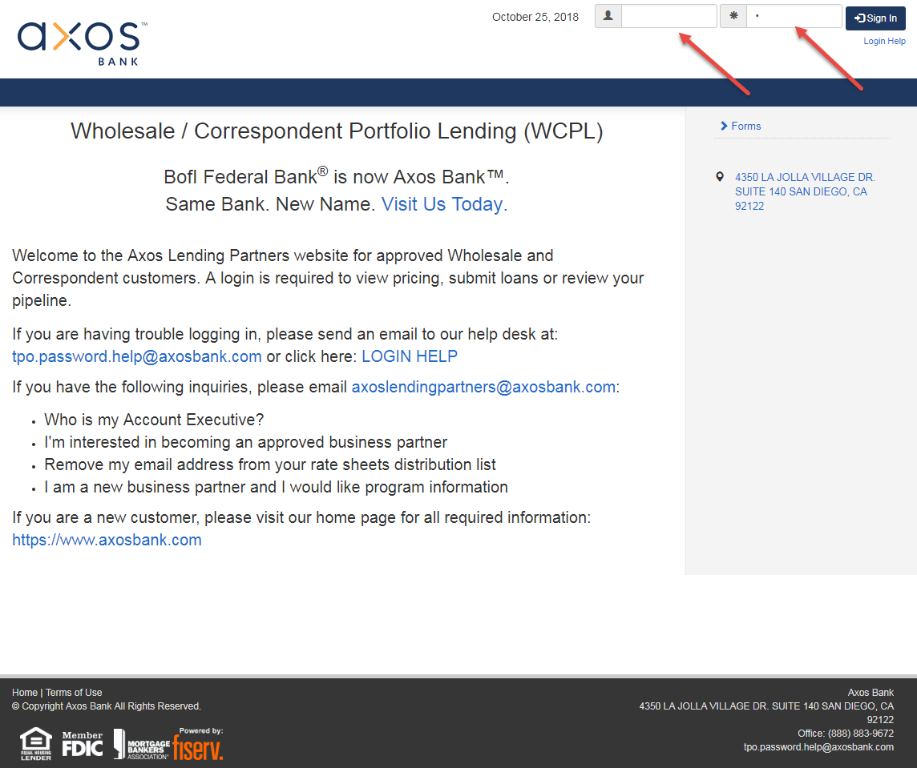

- Once logged in you will see this home page. The home page is where you can upload and register a new loan, upload conditions, view current rate sheets, request rate locks, and view important announcements from
Axos Bank.
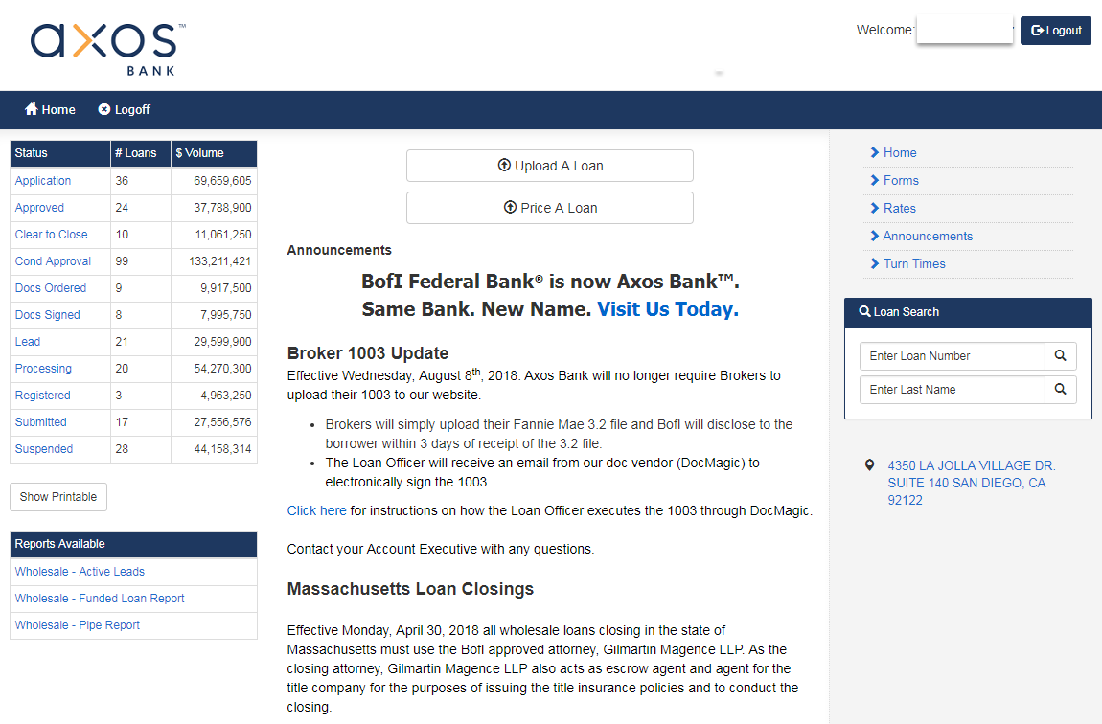

- Please enter either the Axos Bank loan number or borrower last name in the “Loan Search” field and click the magnifying glass icon (search) to find the loan you wish to lock.
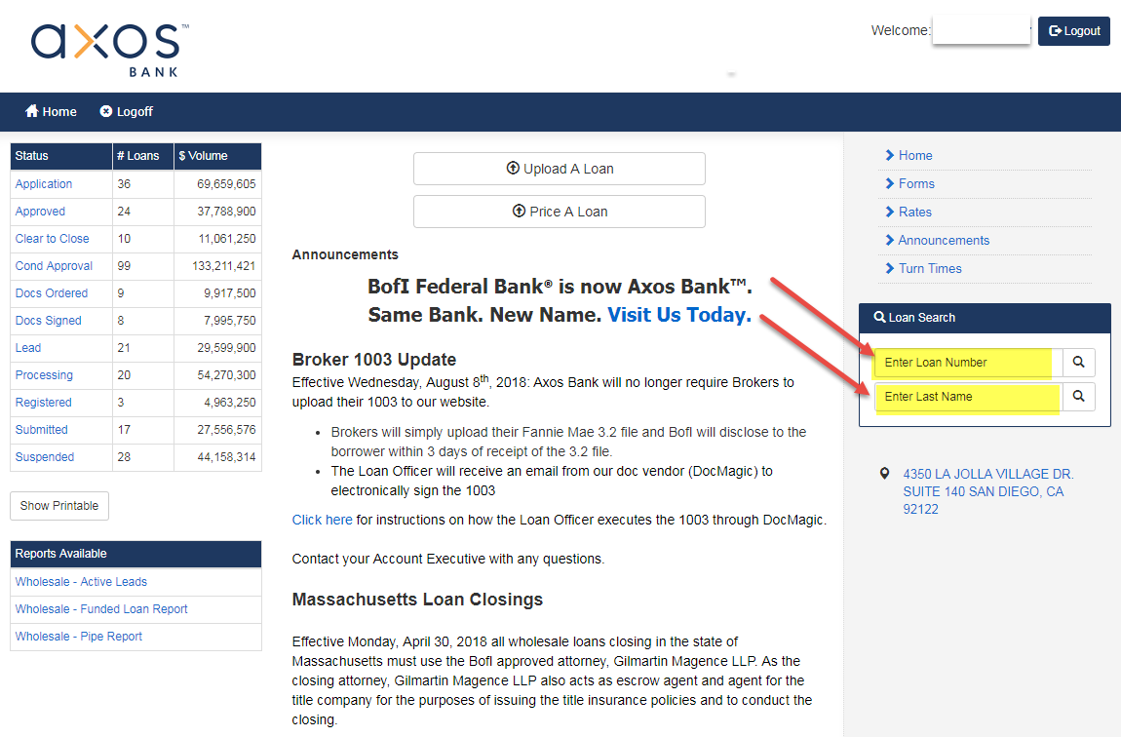

- The next screen that appears shows your Axos Bank loan number, the borrower name, and other loan level information. Please click the “Lock Request” tab.
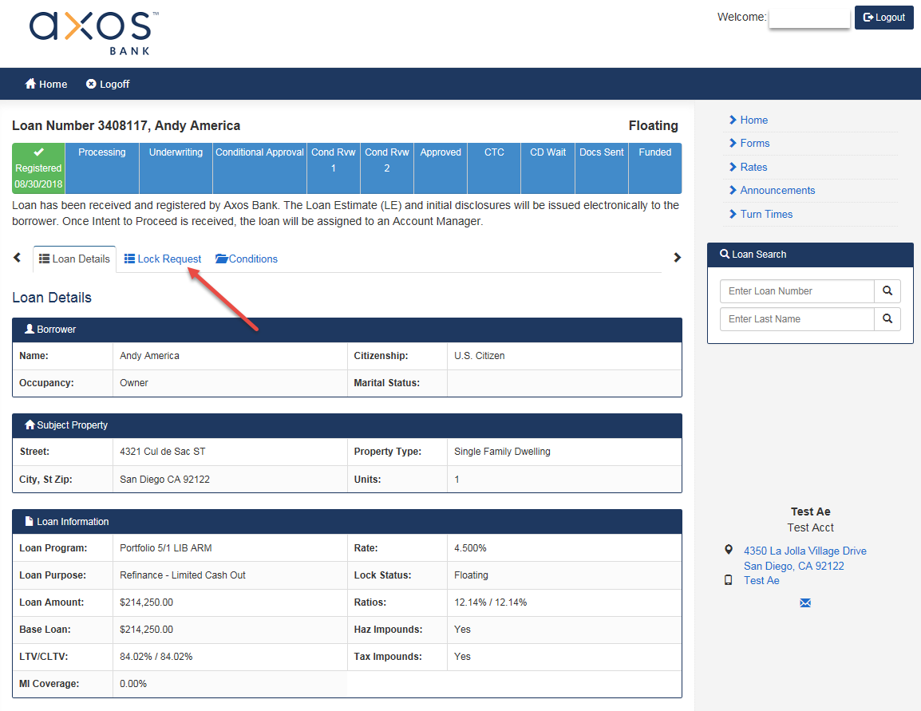

- Lock Request Tab: Please review your loan information to make sure the information is correct. Once satisfied that your information is correct please click the “Price Loan” button shown below.
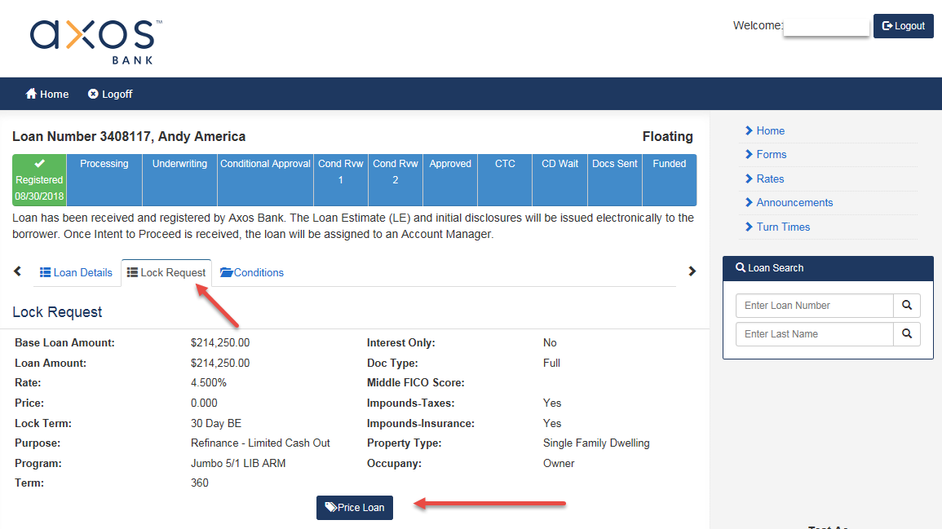

- A new window will appear that has most of the loan information pre-populated. Please review the information and answer all questions marked with a red dot (required). In this section you will be required to select your compensation plan and other special features that may/may not be applicable to your loan.
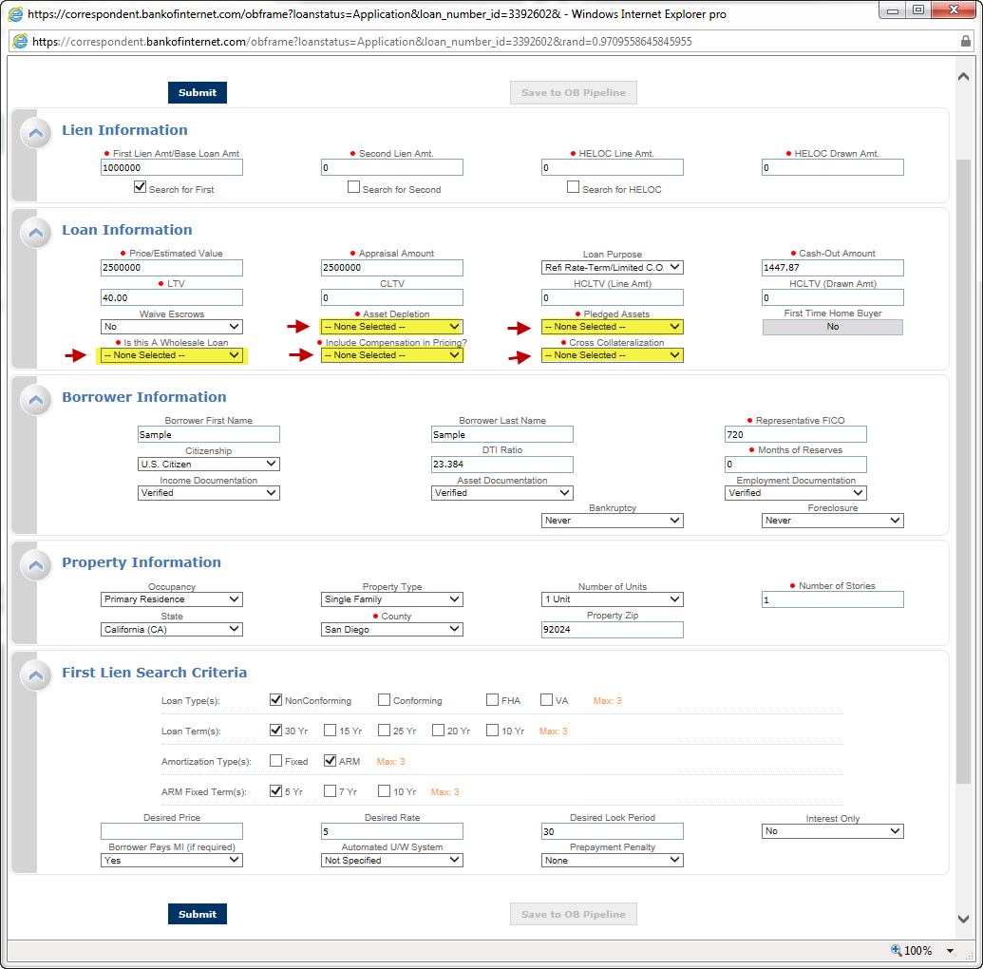

- In this example we will select the compensation plan as Wholesale/Lender Paid (shown below). We offer both Lender Paid and Borrower Paid comp plans for Wholesale partners. If you are a Correspondent partner you would select “No” for the question “Is this a Wholesale Loan” and “No” for the question “Include Compensation in Pricing”.
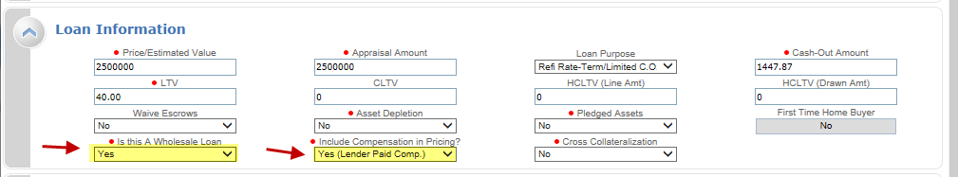

- At this point once you are able to request pricing. Simply click either of the “Submit” buttons located on the top and bottom of the page.
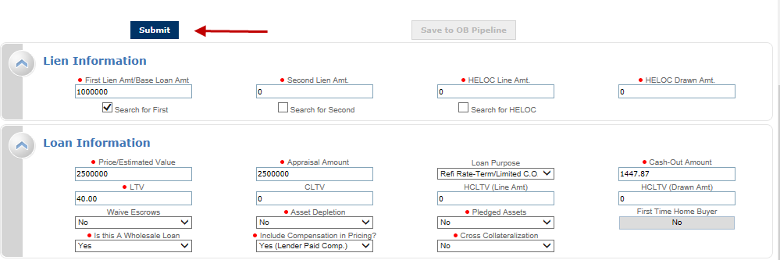

- The next screen that appears is the rate stack for the program. The orange line shows the pricing for the rate you have selected within your loan submission. Click the price under the appropriate lock term to move to the final lock request screen (shown below). The screen shot below shows we selected 5% @ 99.844 for 21 days as an example.
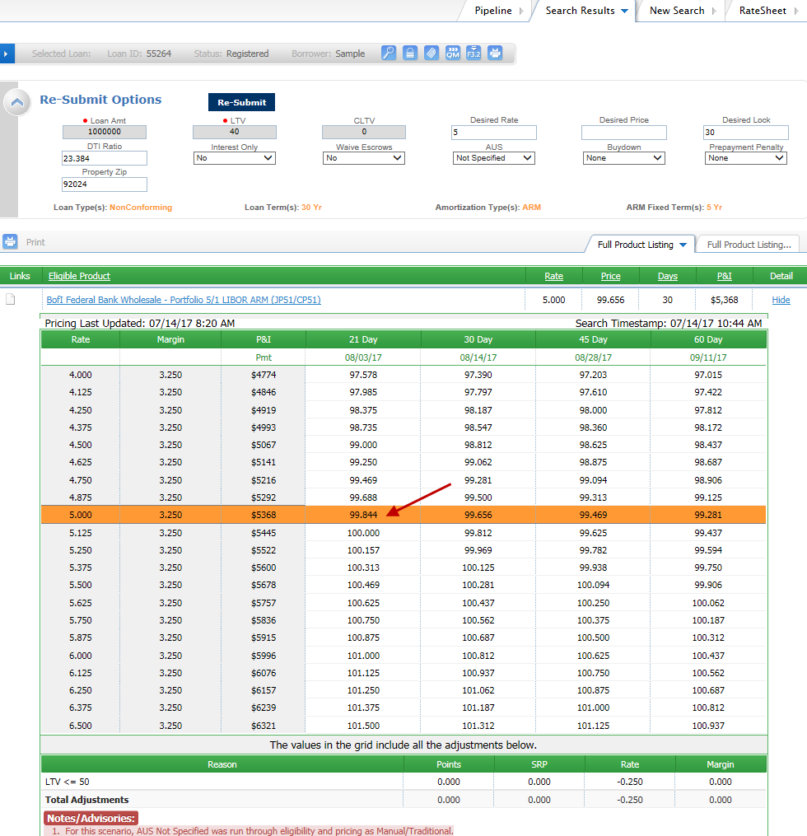

- After selecting the price you will see the summary page. On this page you will see the “Request Lock/Save to LOS” button. Make sure to complete the field for the email address you want the lock confirmation sent to, it is a required field. Once you have completed the email field you are able to request rate lock. Click “Request Lock/Save to LOS” to submit the lock request.
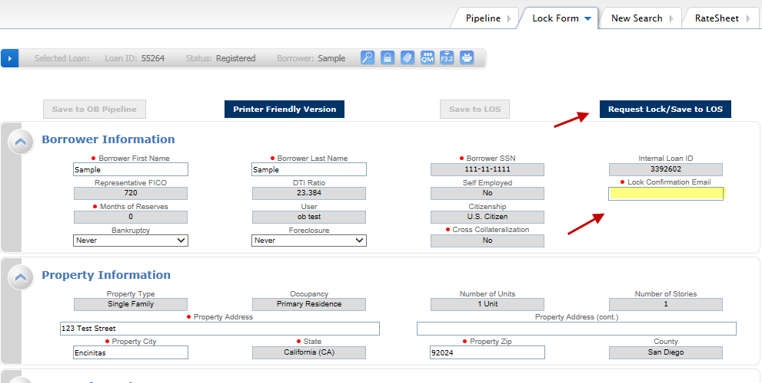
- After you click the “Request Lock/Save to LOS” button you will see a final message that shows your rate lock was submitted.
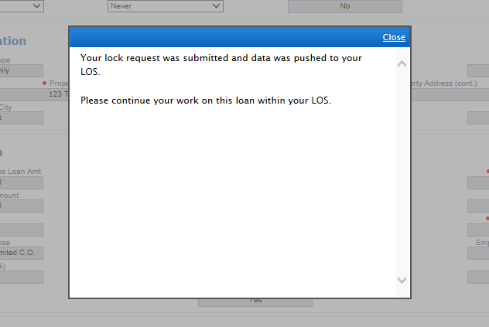
Helpful tips for successful use of the Optimal Blue interface.

- Rate changes: If your loan is “Approved” you will not be able to make changes to the rate through the Optimal Blue interface. Rate changes on approved loans will need to be reviewed by the underwriter to ensure the DTI increase does not affect the overall eligibility of the loan. If you need to make a change please contact your Account Manager, the Lock Desk, or your Account Executive to initiate the change request. Changes are generally completed very quickly for most cases.
- Required fields: Please review the required fields thoroughly. Your loan approval will note whether your loan was approved with Asset Depletion, Pledged Assets, or Cross Collateralization. Please make sure to select yes or no for these questions as you will not be able to move forward without answering
- Comp plans: Please make sure to select the appropriate comp plan for your loan. If you are a Wholesale Broker you will have the choice of Lender Paid or Borrower Paid compensation. Please make sure to select the correct comp plans as there is a large pricing difference between the two plans. Correspondents will always choose “borrower paid” in the comp plan selection.
- If you have questions or need help please email lockdesk@axosbank.com.

Effective Date 01/22/2018

